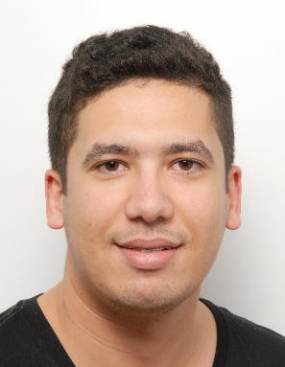Aymen Mahmoudi (23 years old)

Tel: +33 (0)7 49 16 86 05 / +33 (0)6 05 53 00 44 (WhatsApp)

E-mail: mahmoudi7050@gmail.com

Address: 31 Avenue Prof FOULON (Room 120 D) 35700 RENNES-FRANCE

Education :

* 2019 : Master degree in Fundamental Physics : Nanosciences specialty (University of Rennes 1)

( Major of the promotion in M1 )

Materials Physics, Solid State Physics, Advanced Quantum Mechanics, Programming

* 2016-2019 : Bachelor's degree (Faculty of Sciences of Tunis)

Classical physics, General chemistry, Mathematics, Hyperfrequency, Wave physics, Restricted relativity, Electromagnetism, Experimental physics, Electronics, Thermodynamics, Particle physics, Solid state physics, Quantum mechanics.

(National laureate for 3 years)

* Internship (level: M1) in “ Institut de Physique de Rennes IPR ” under the direction of Ms. Ababou-Girard Soraya on the analysis of functionalized surfaces using XPS spectroscopy.
* Summer internship (level: L3) at the LSAMA laboratory of the University of Tunis under the direction of Mr GHALILA Hassen on the analysis of radiofrequencies triggered by lightning and estimation of distances to the sources using a single VLF sensor.
* Advanced Training Course in Astronomy and Astronomical Observation Techniques.

Conferences:

* International Symposium on Astronomy organized by the Tunisian Association of Astronomy (SAT) in Djerba in 2018.
* Program of the Dynamization of cultural life university organized by the Ministry of Higher Education.
* 5th African Regional Congress of the International Radiation Protection Association (AFRIRPA 5) in Tunis in 2018.
* The STP Spring and Winter Schools on Magnetism and Computational physics in 2018 and 2019.
* Hackathon (Hack for Democracy H4D) in 2017(competition).

Languages:

Arabic (mother tongue) French (advanced) English (advanced) German (beginner)

Computing skills:

* Basic computer software for Windows and Linux.
* Python, C++, MATLAB, Latex, Arduino.

Interests:

* Scientific News: Conferences, Science Clubs and Associations, Documentaries, movies ...
* Volunteer work: First aid, Civil associations, Clubs...
* Personnel development: NLP, Emotional intelligence …